**REX User Manual**

**(Test Scenarios)**

**Facility KNEE/ KNEX**

**Unit Characteristics Used**

**K1X_REX_Method**

**Attribute Used**

LU_BASED_REX_USING_MAV

STANDARD_REX

**K1X_POE_MATERIALCALL**

**Attribute Used**

LUBASED_MATERIALCALL_USINGMAV

STANDARD_MATERIALCALL

**Case 1**

**Facility KNEE /KNEX**

**Go to unit Characteristics K1X_POE_MATERIALCALL**

**TO Creation (OLD)**

**REX Execution (New)**

**Screen POE**

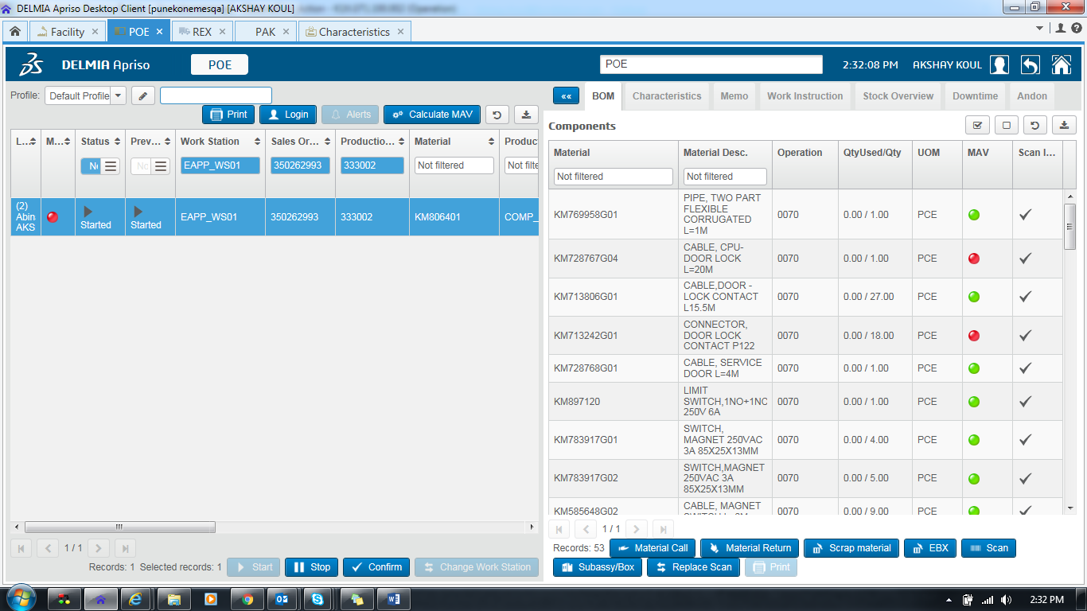

Here if we don’t select any material it will ask for component

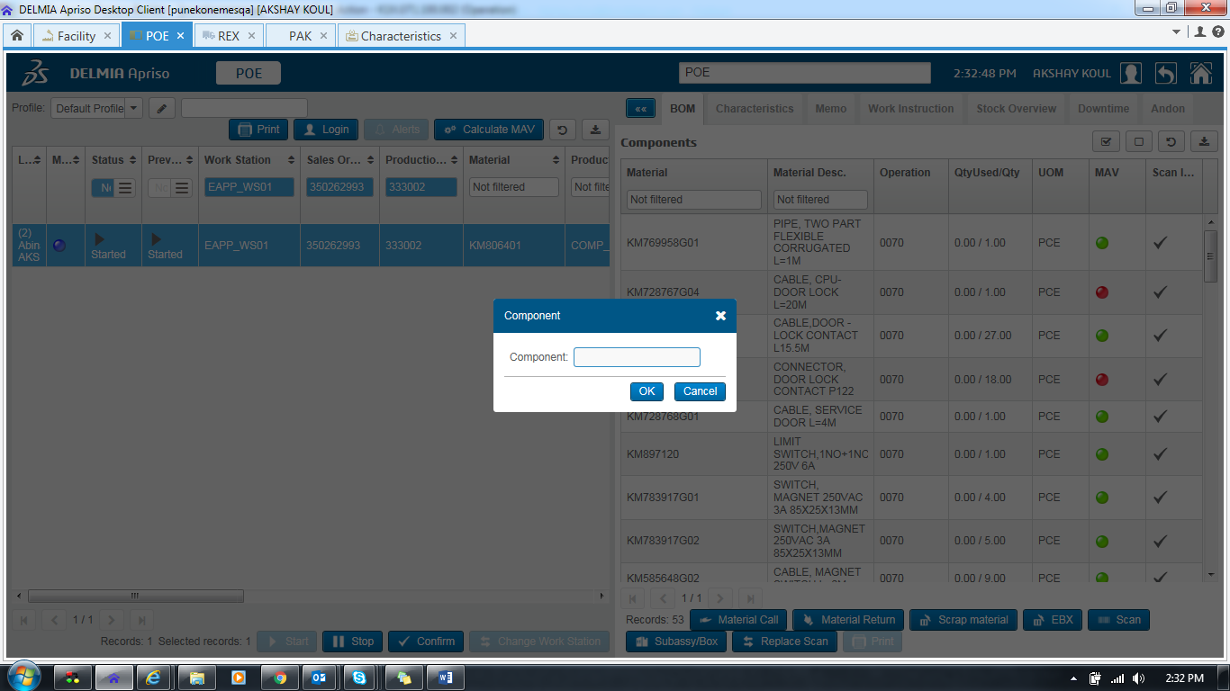

After Material Selection for selected material it will create TO

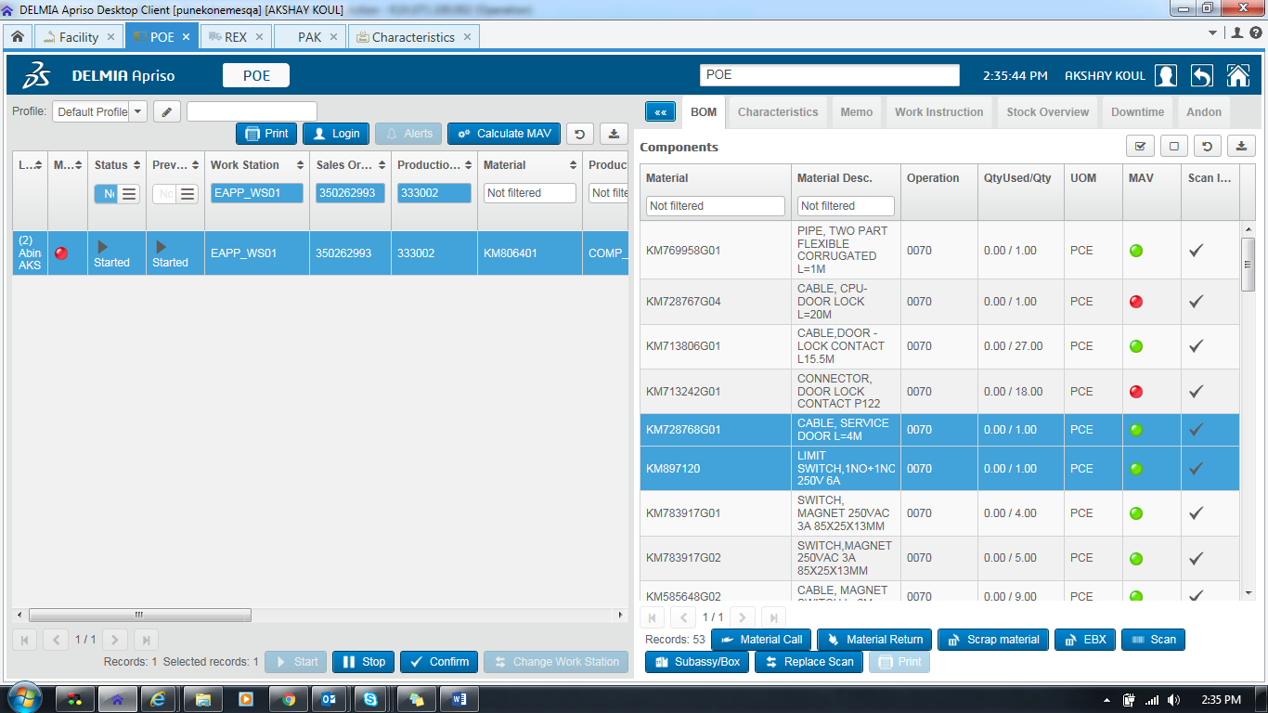

Click on Material Call for TO Creation

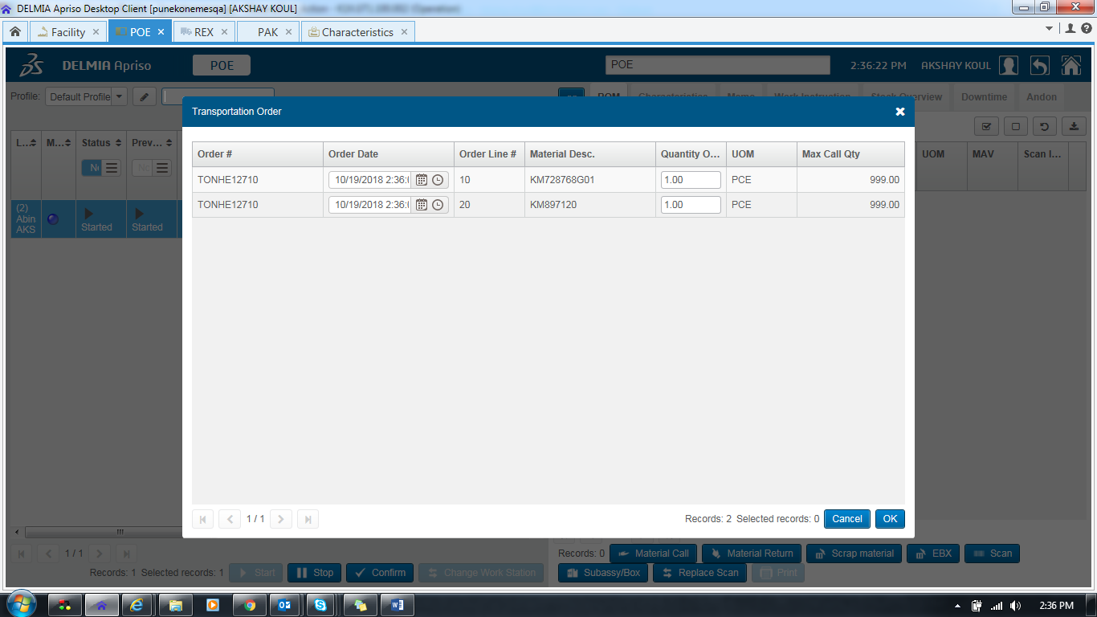

TO is created for selected Material

Now Navigate to REX screen

Here you can see TO is generated for above selected material only .

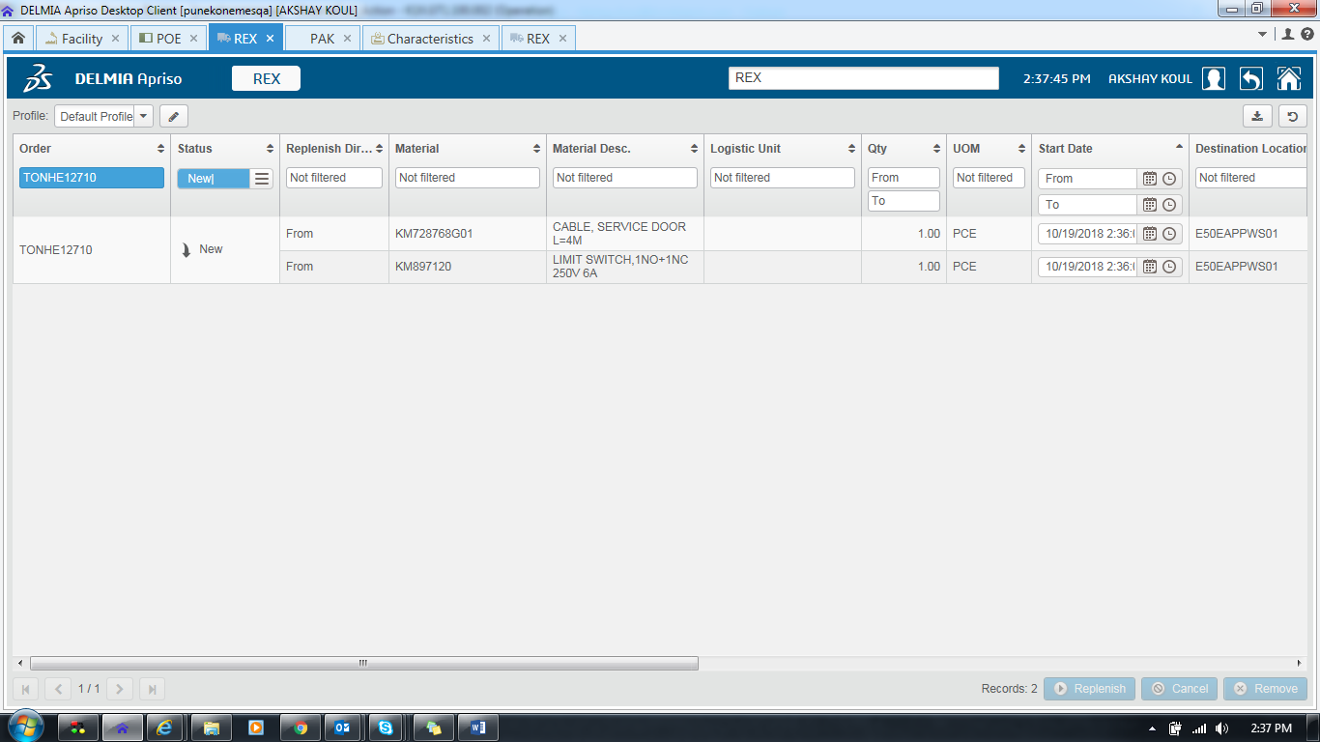

Click on Replenish

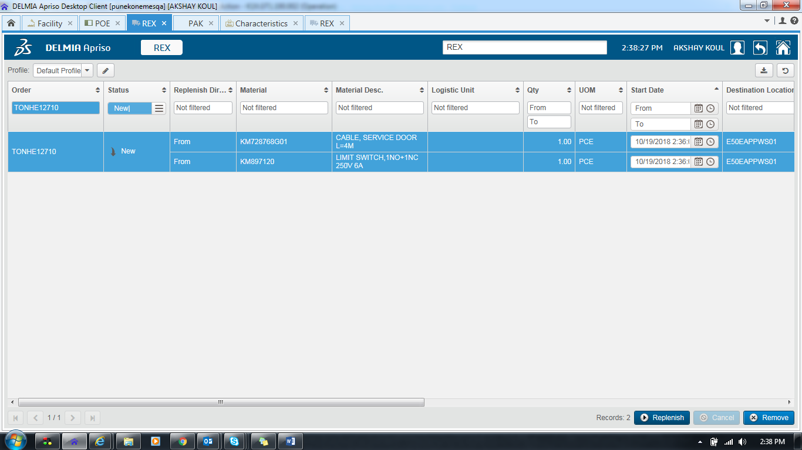

Here User will be able to see New REX execution

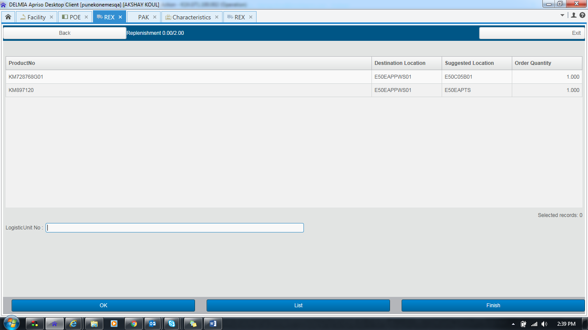

Proceed to Replenish enter LU

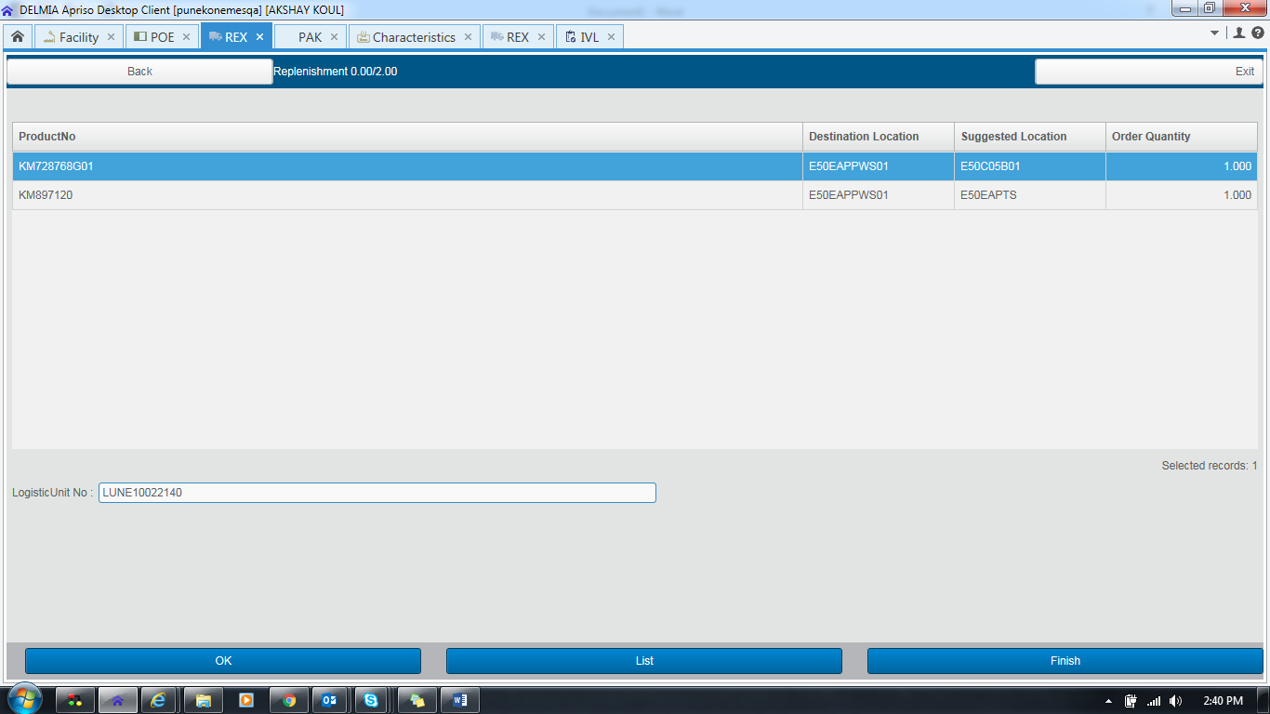

Click On OK Button

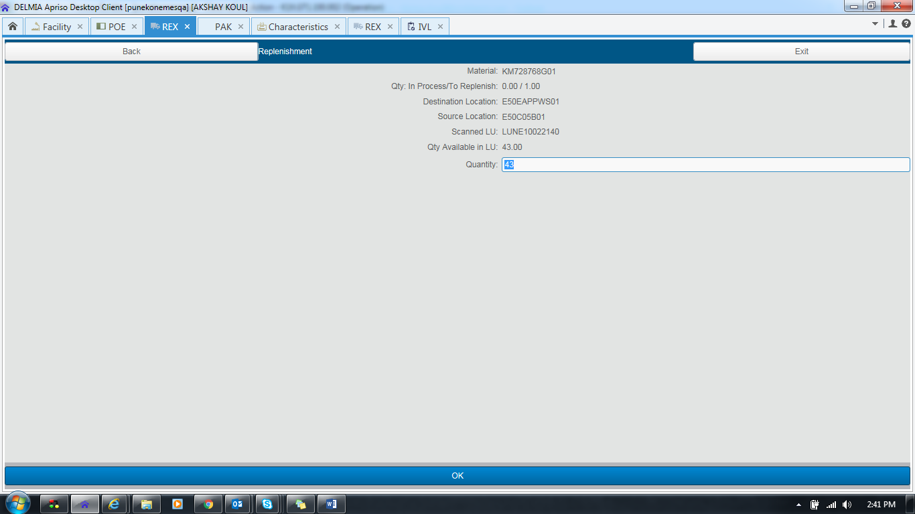

Click OK

Here You can see Material is removed as expected for REX Execution

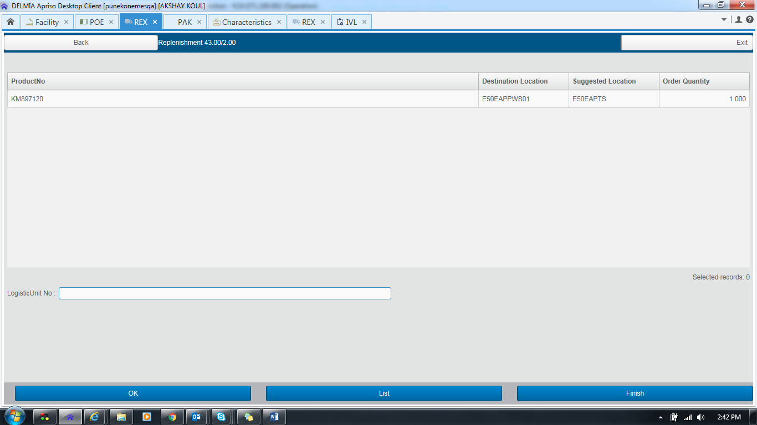

If user wants to do Partial Replenishment

Then click on Finish -> Yes->

Enter Location Then click on **Partial Button**

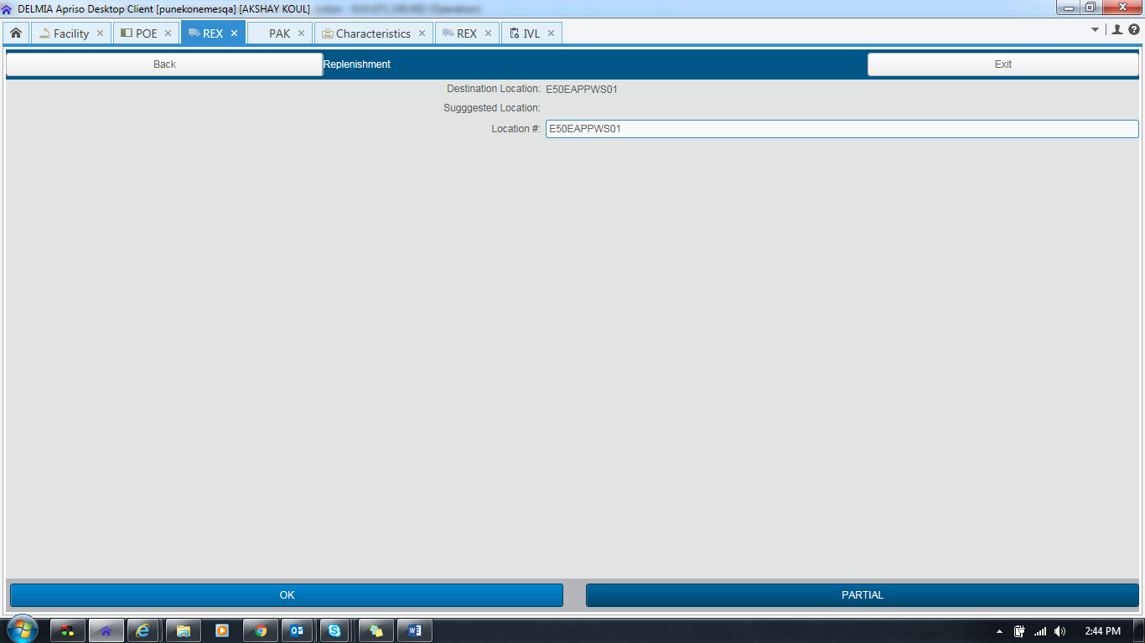

Then Check TO will be in Started State As expected

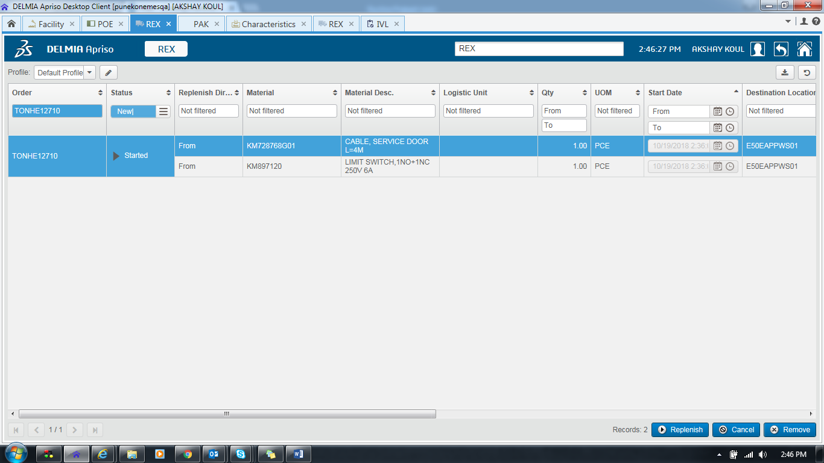

Here user Can Replenish Remaining Material and do full replenishment.

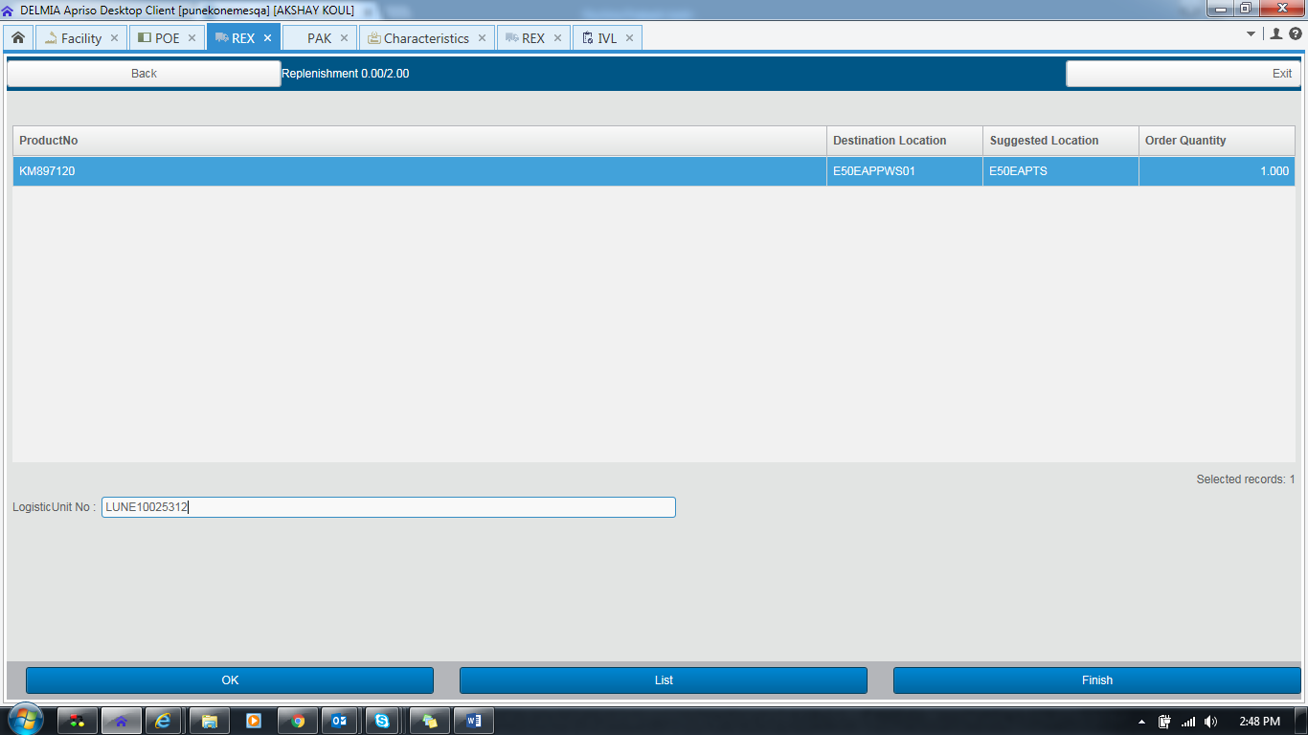

Click on OK

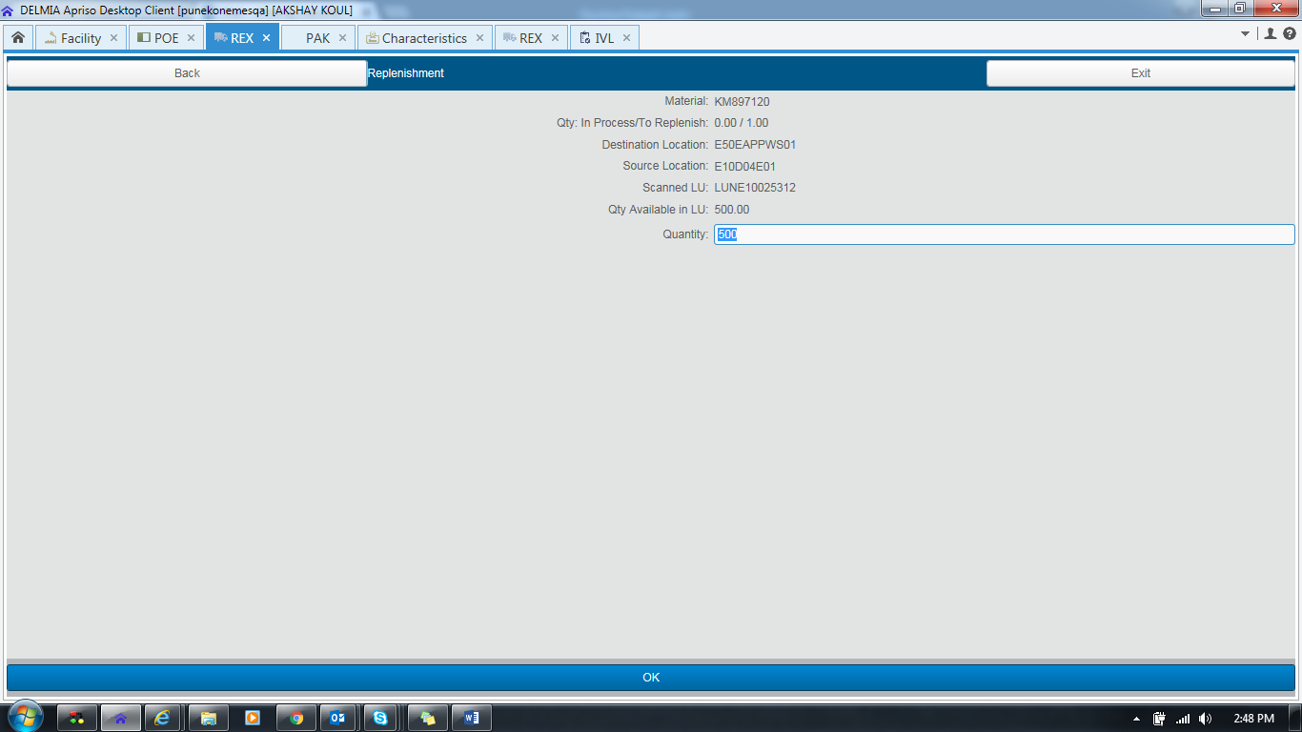

No Material As expected

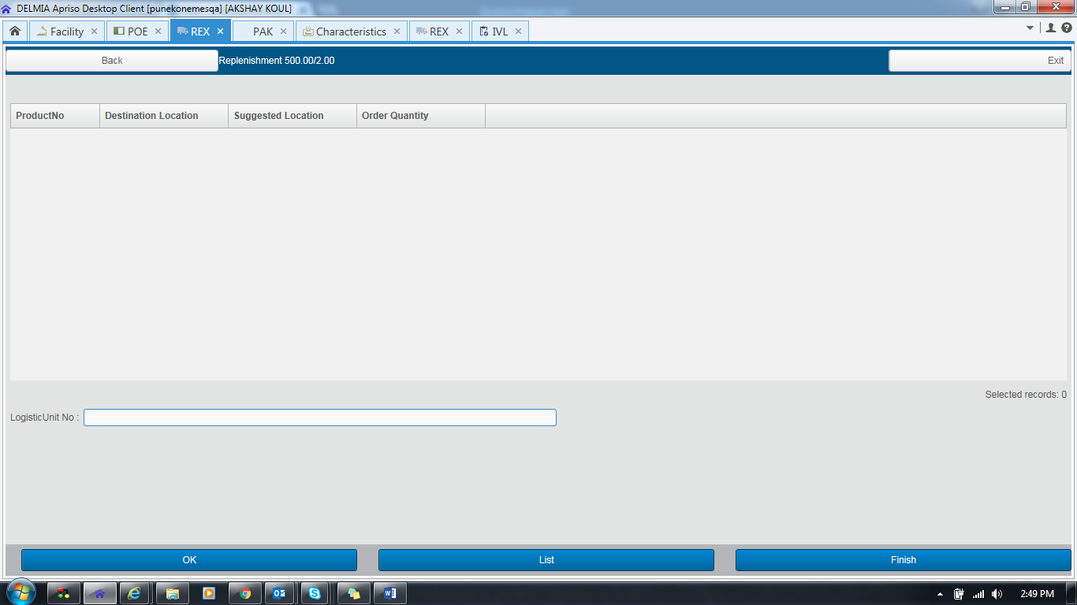

Click on finish

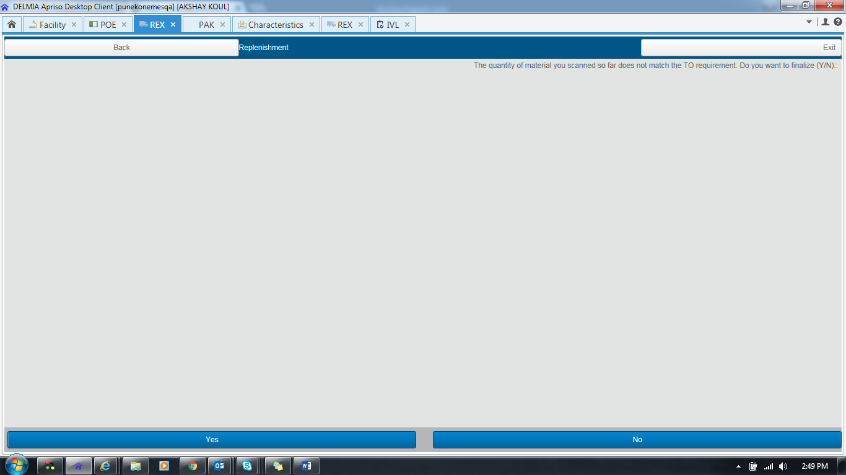

Click on Yes

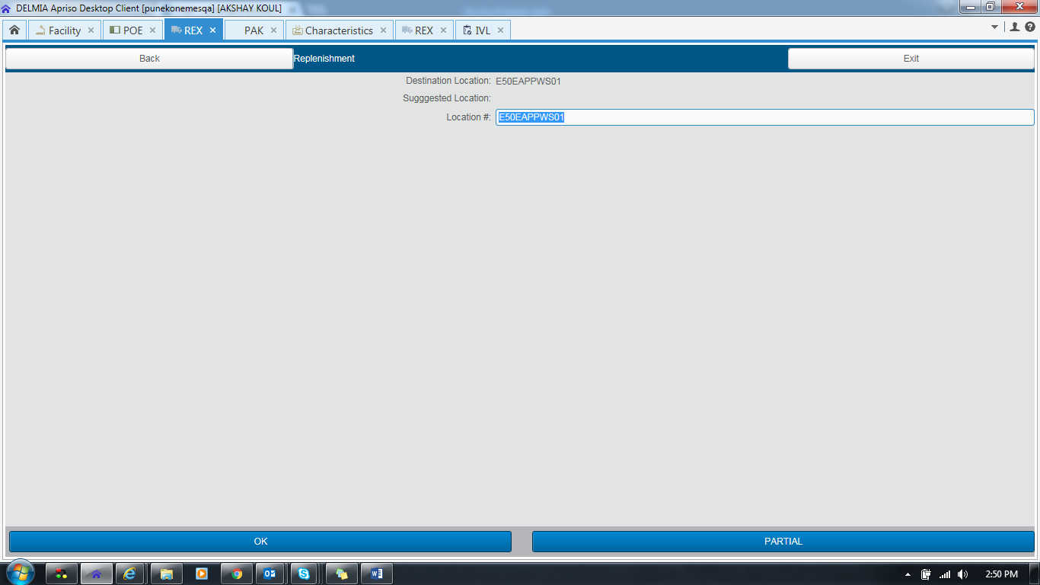

Click On OK and do Full Replenishment.

Here user can see replenished Material

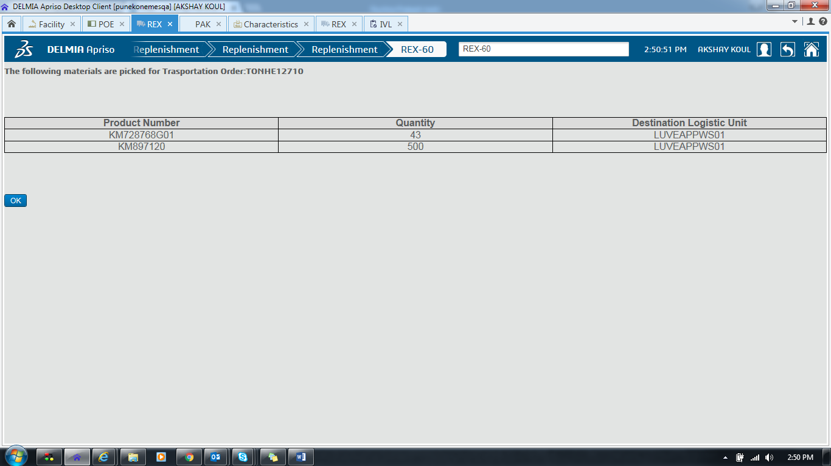

Click On OK

TO will be closed as Expected

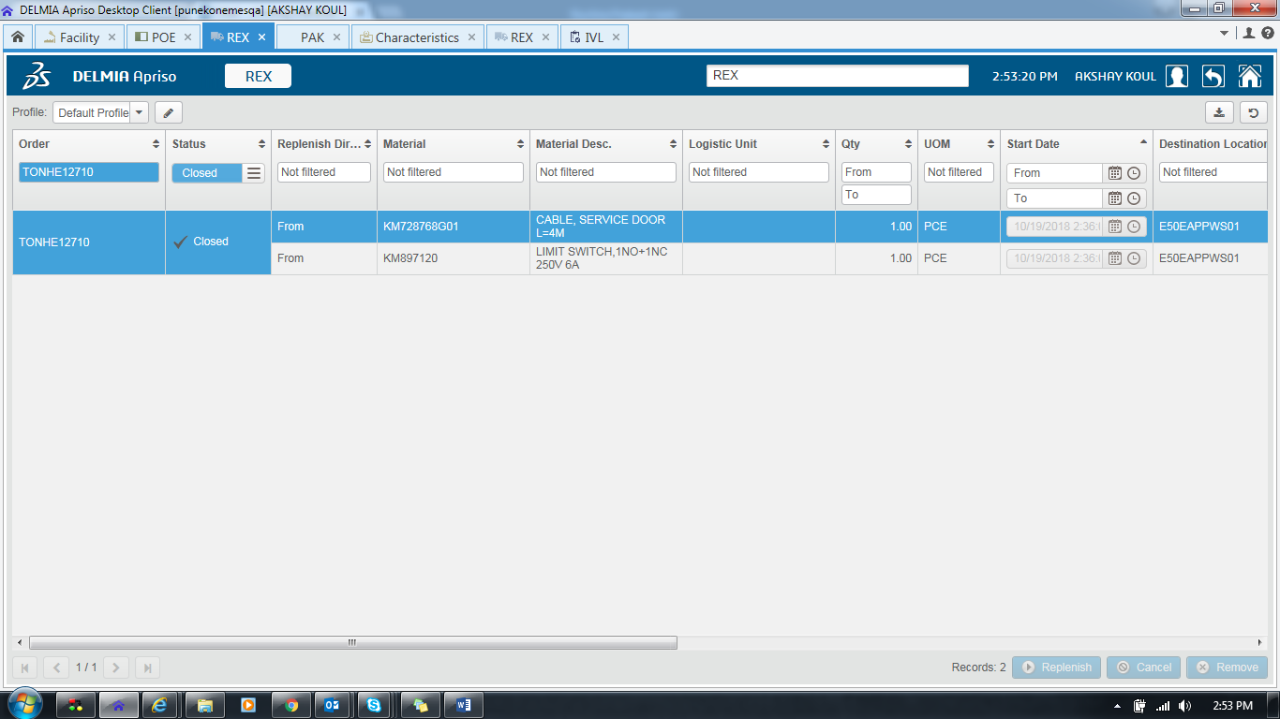

Case 2

TO Creation NEW

REX Execution OLD

Facility KNEE

Go to unit Characteristics K1X_POE_MATERIALCALL

TO Creation (NEW)

REX Execution (OLD) Unit Characteristics K1X_REX_Method

Attribute Standard_REX

Screen POE

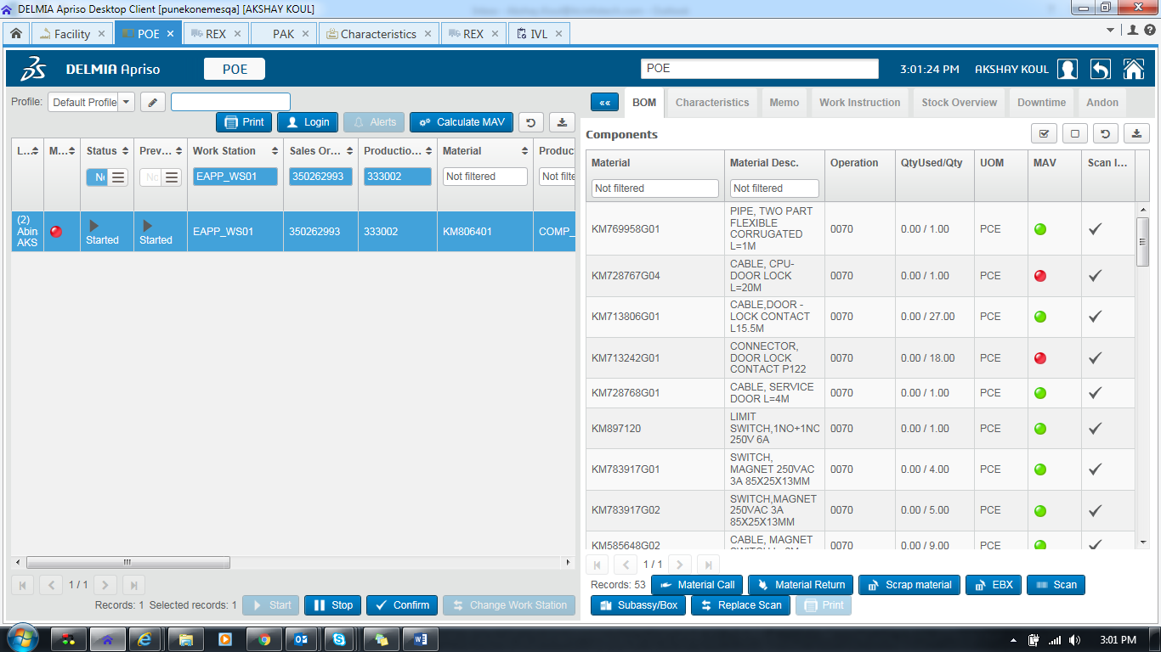

Click on Material Call TO should be Created for Grey Red Orange Based on MAV

Result As expected

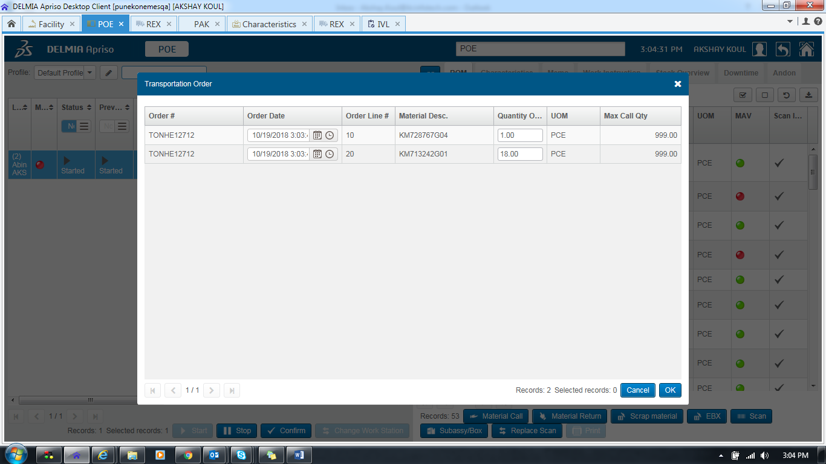

Go to REX

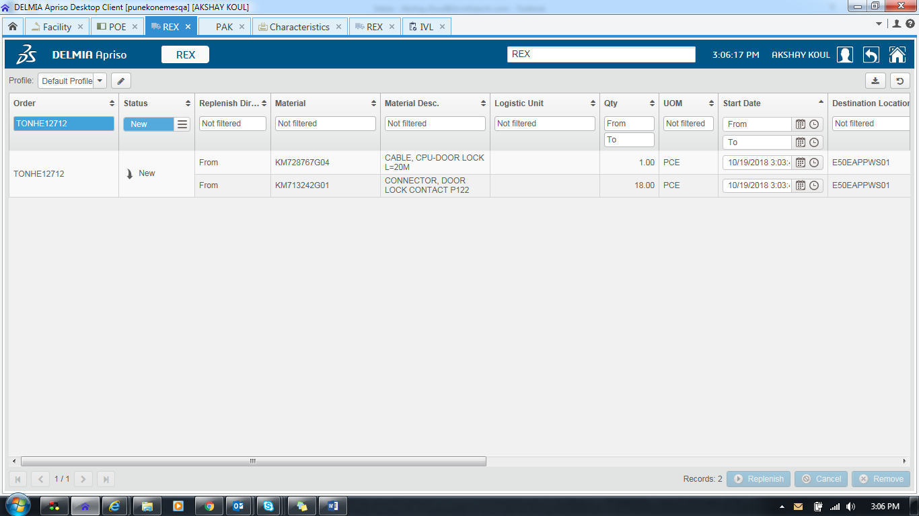

In Case 2 REX Execution Should be OLD

REX Execution OLD

Here User is able to See REX execution in old manner

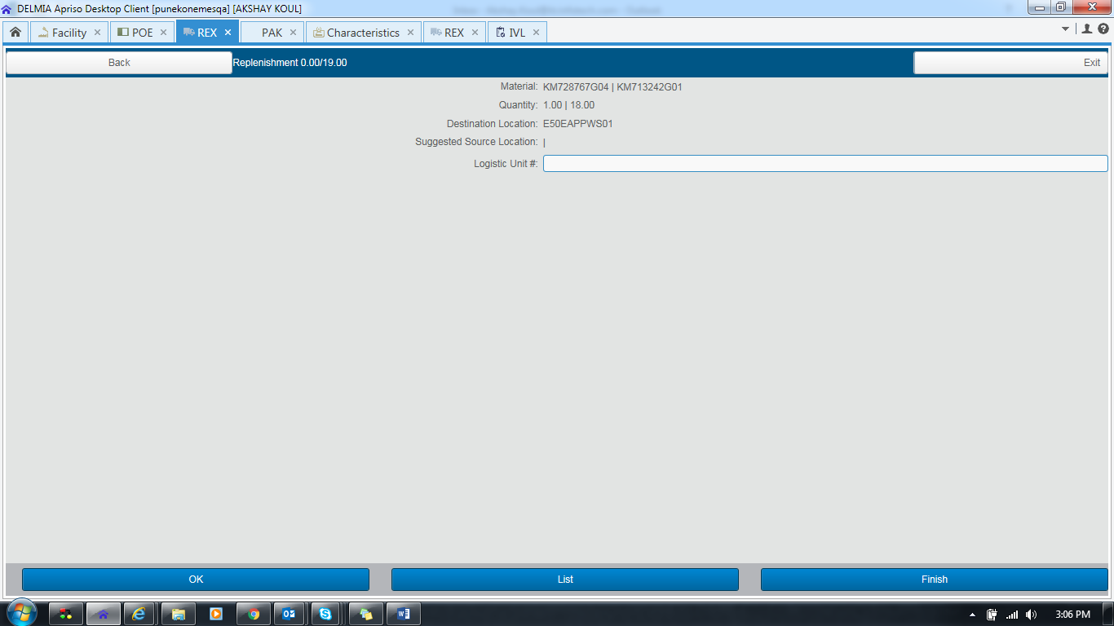

Enter LU

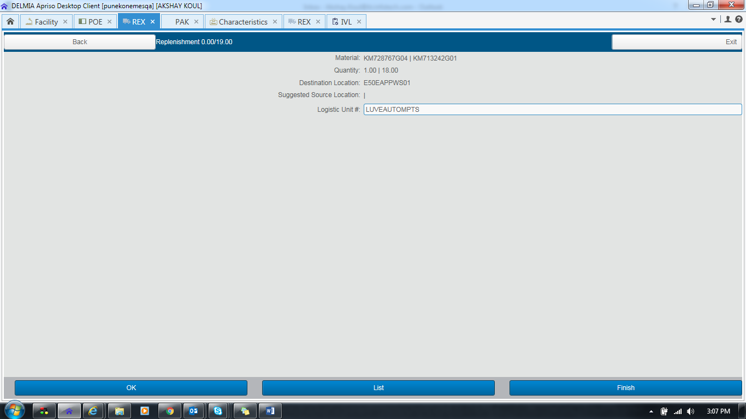

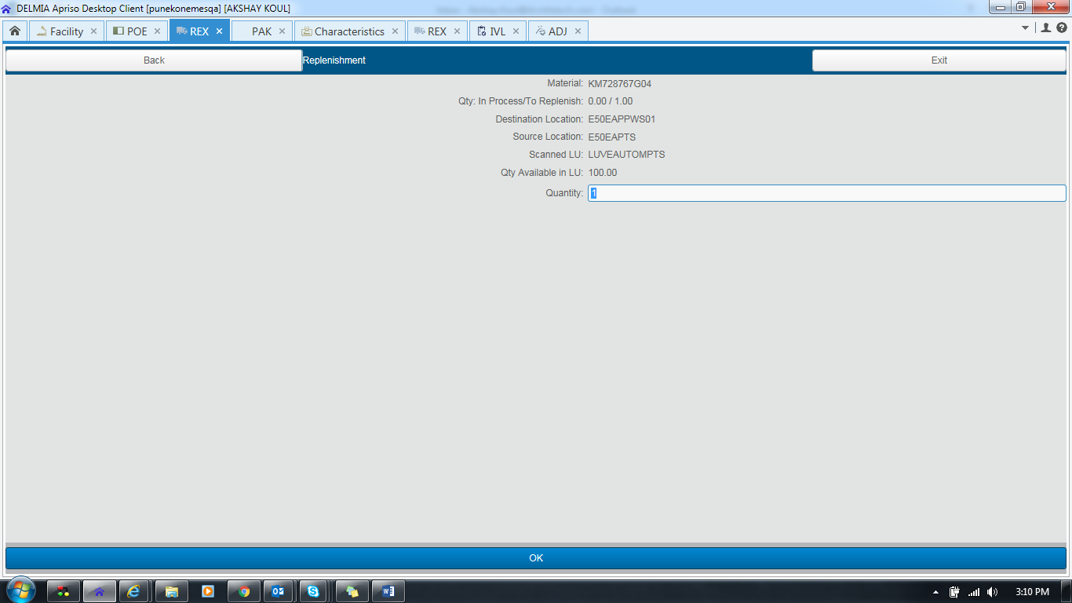

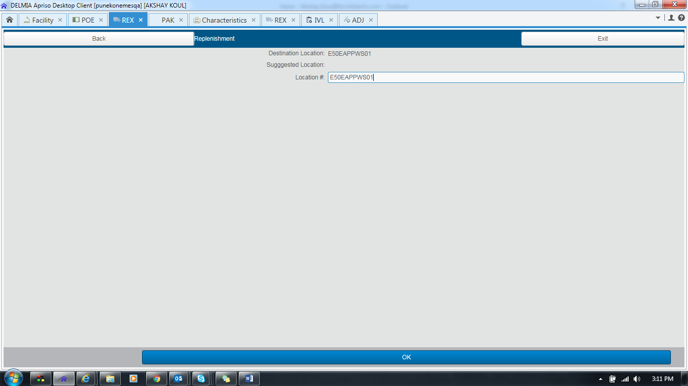

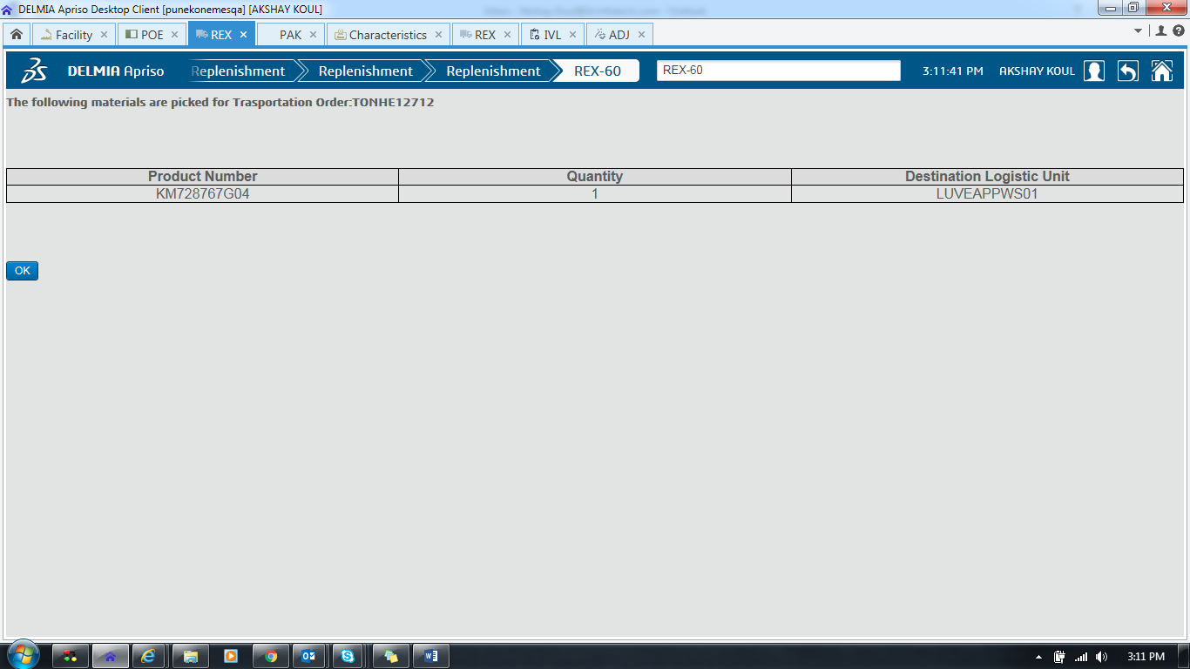

**Case 3**

**TO Creation OLD**

**REX Execution OLD**

**Facility KNEE /KNEX**

**Go to unit Characteristics K1X_POE_MATERIALCALL**

**Attribute STANDARD_MATERIALCALL**

**TO Creation (NEW)**

**REX Execution (OLD) Unit Characteristics K1X_REX_Method**

**Attribute Standard_REX**

**Screen POE**

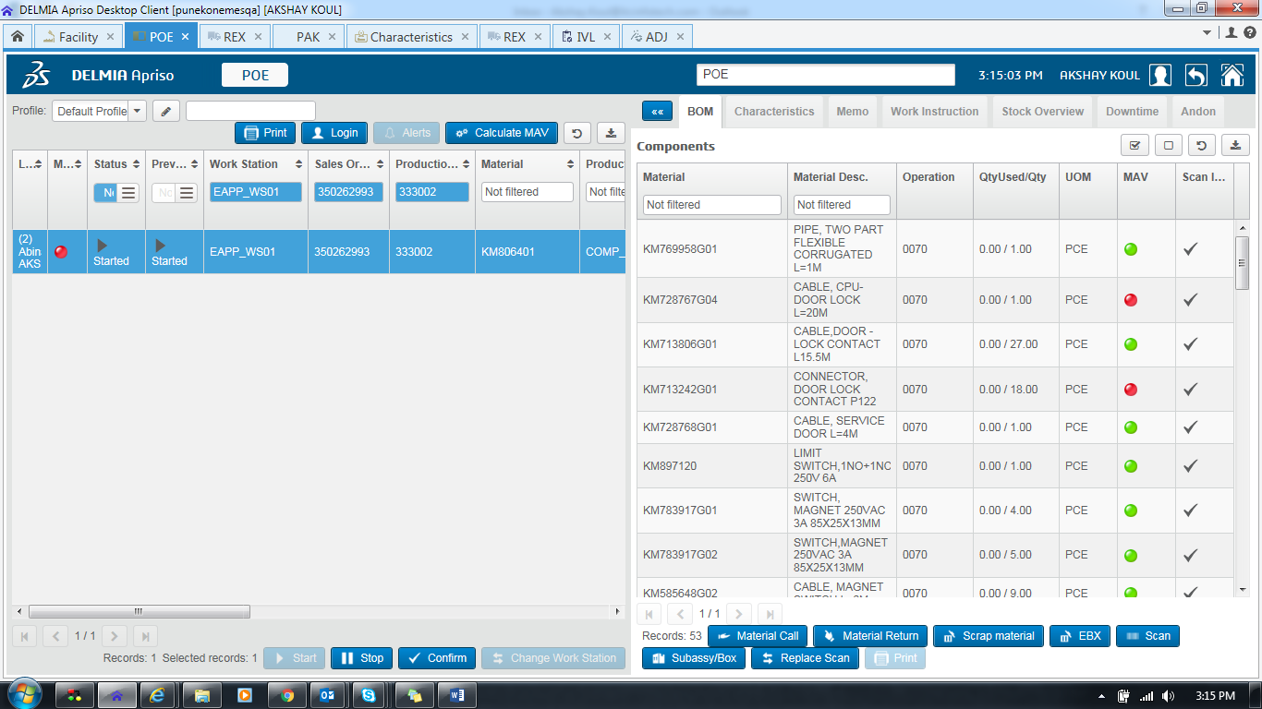

As Expected Select Material otherwise it will ask for Component

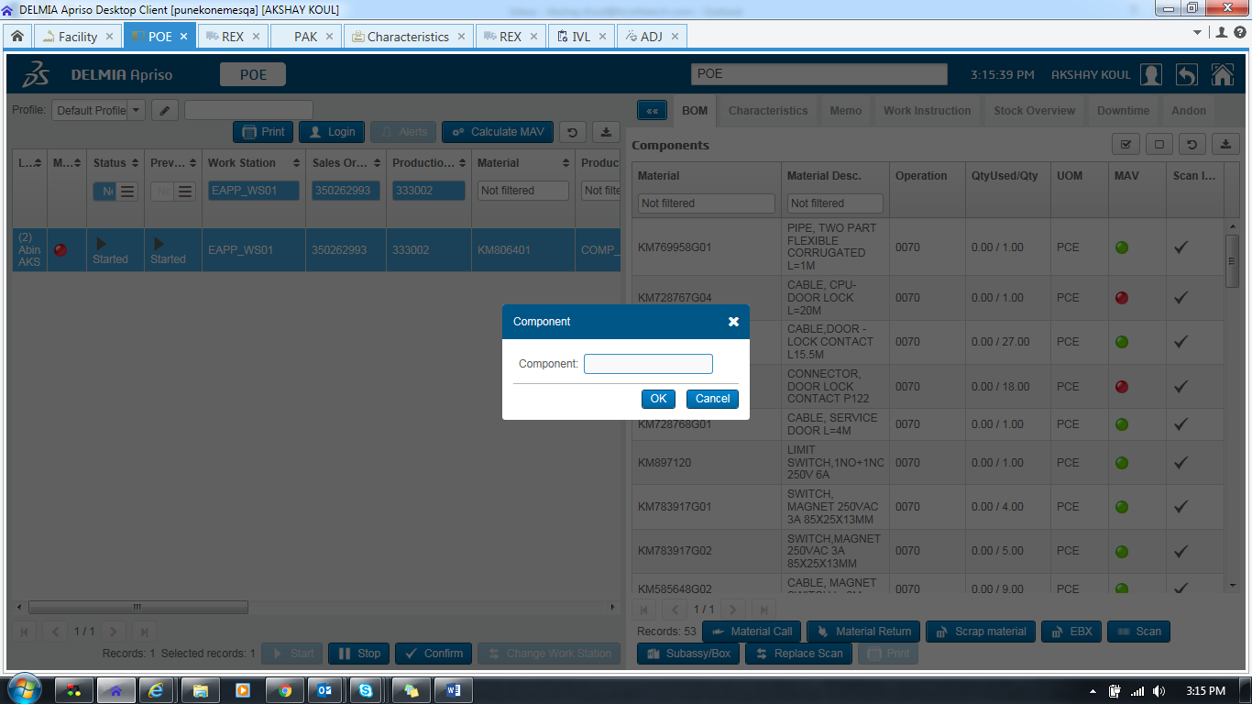

Select Material

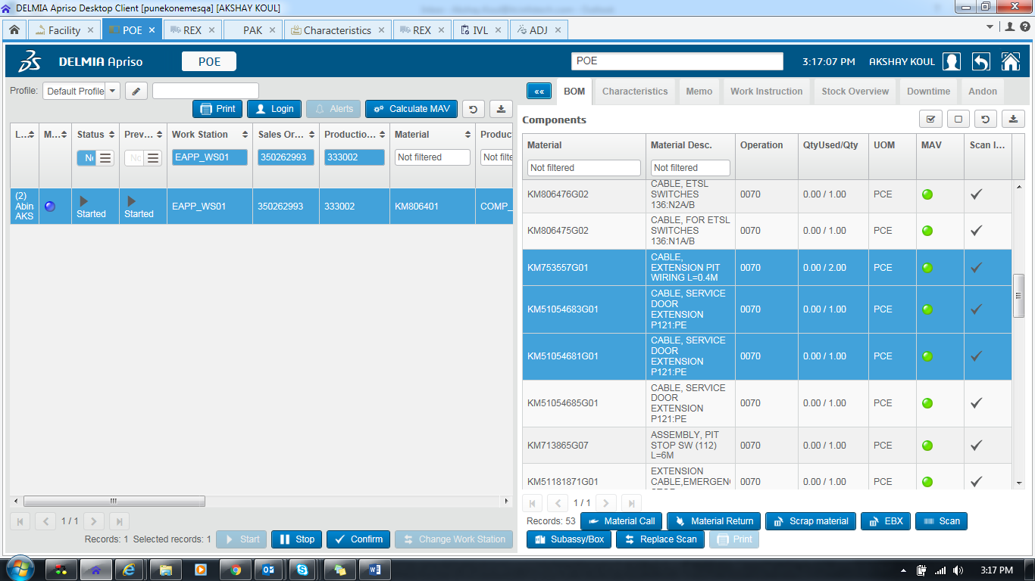

Click On Material Call

TO should be generated for selected Material Only

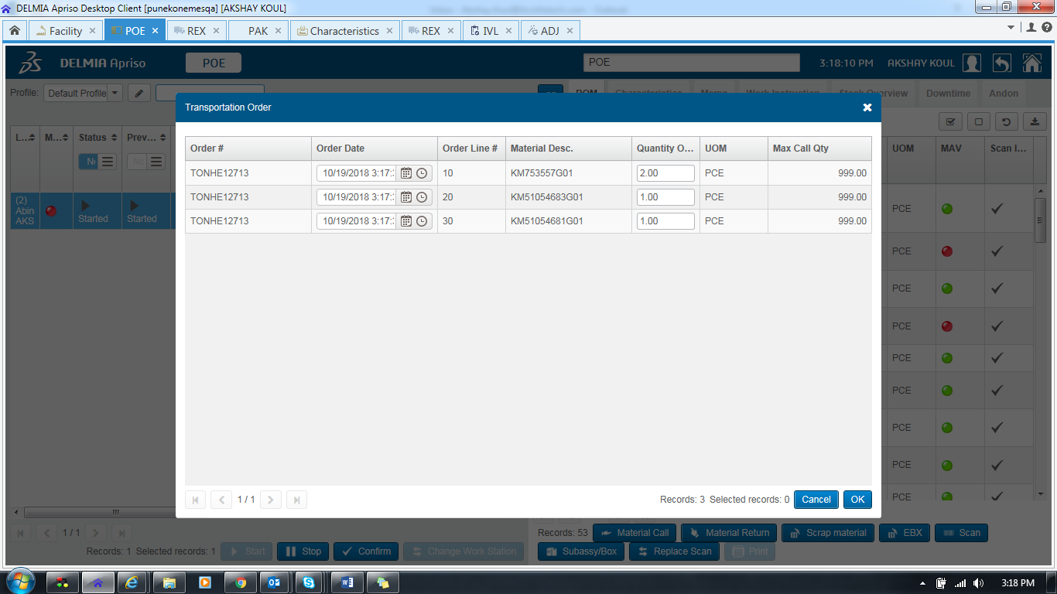

Navigate to REX

REX Execution OLD

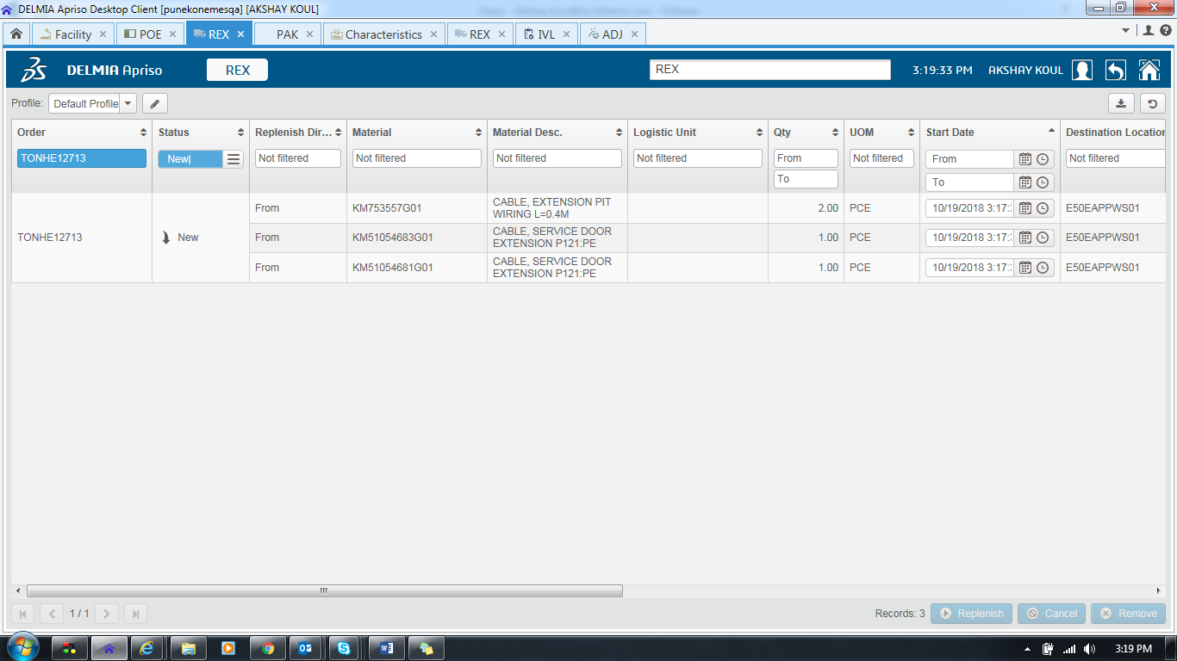

Rex Execution as expected OLD

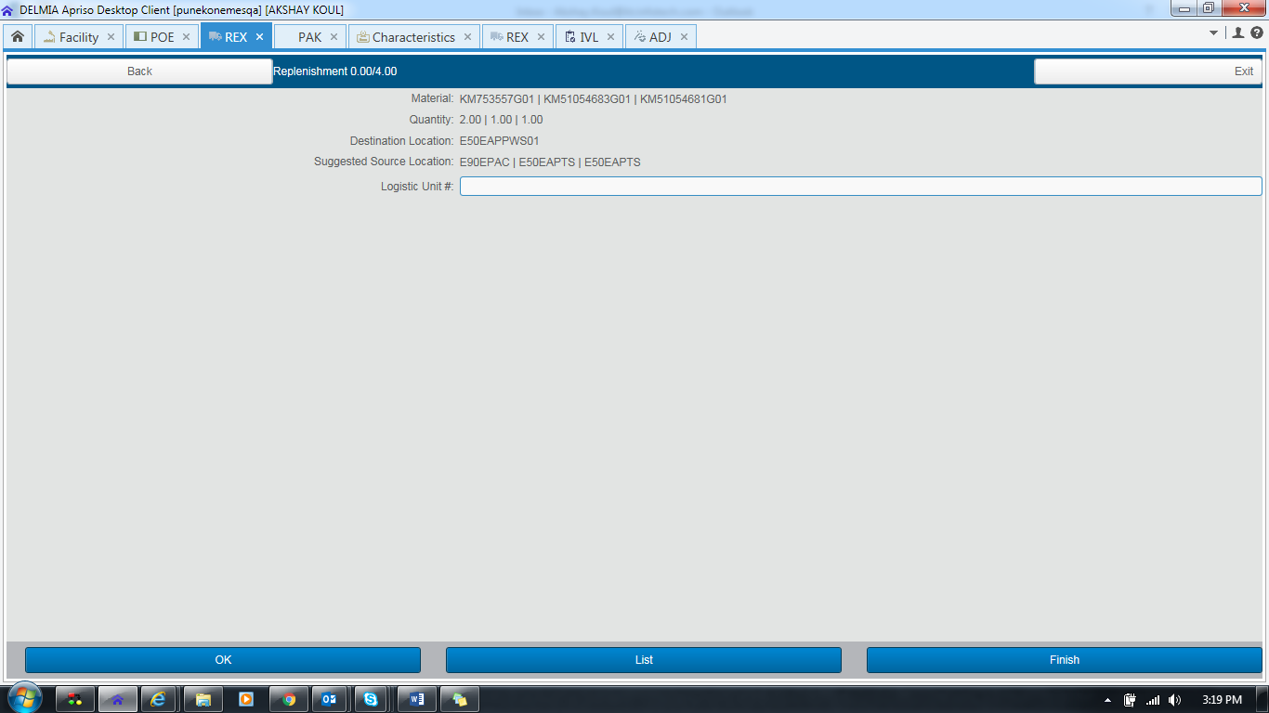

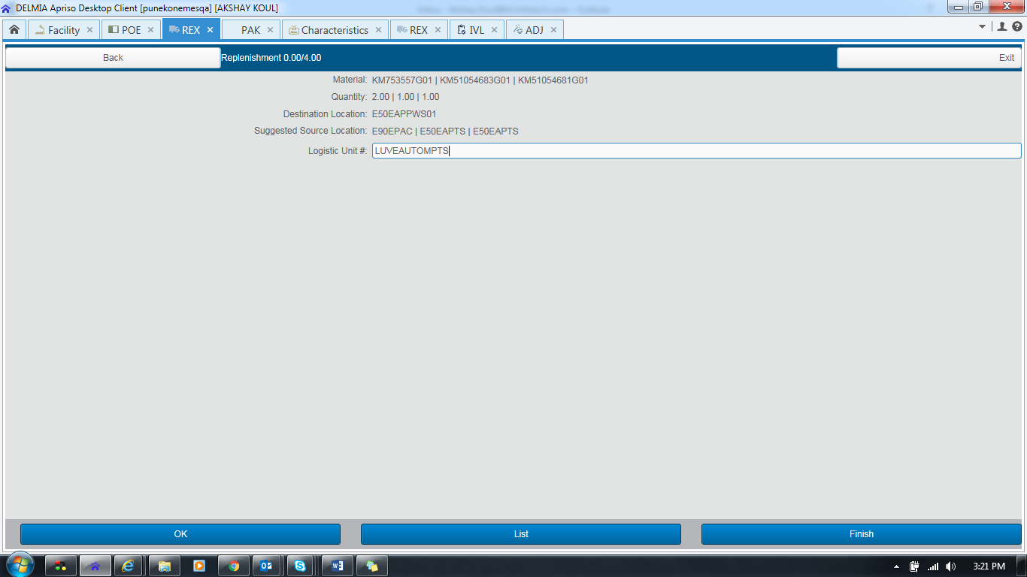

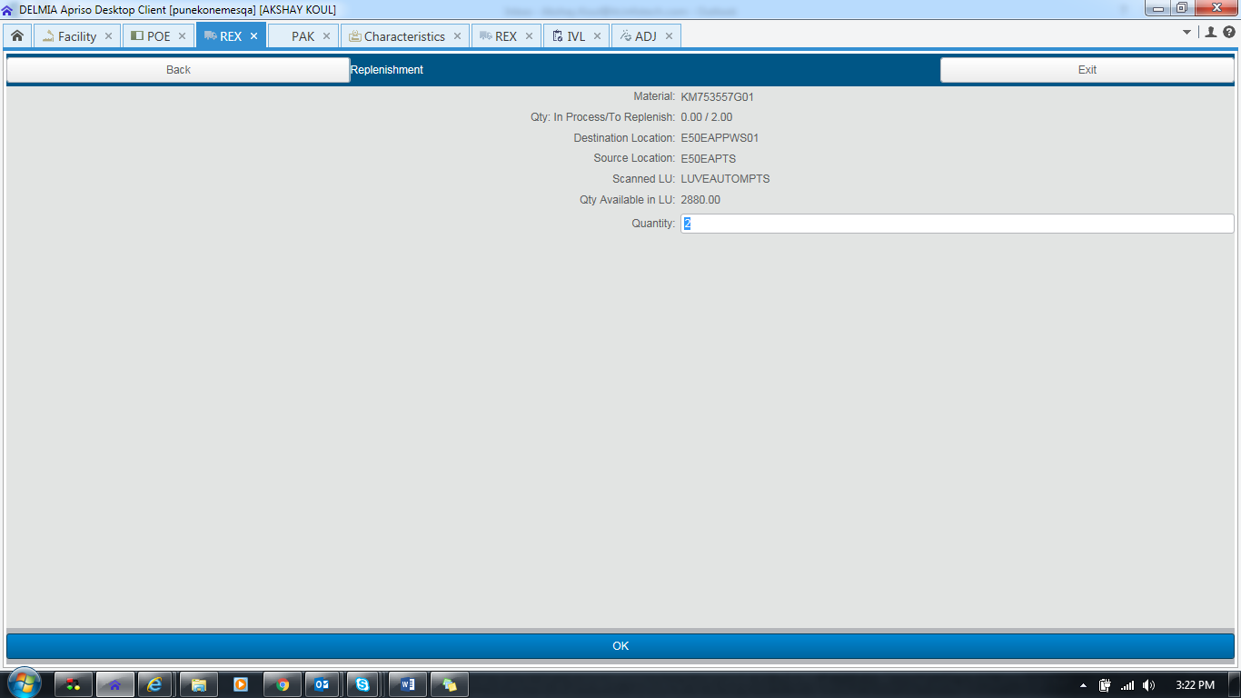

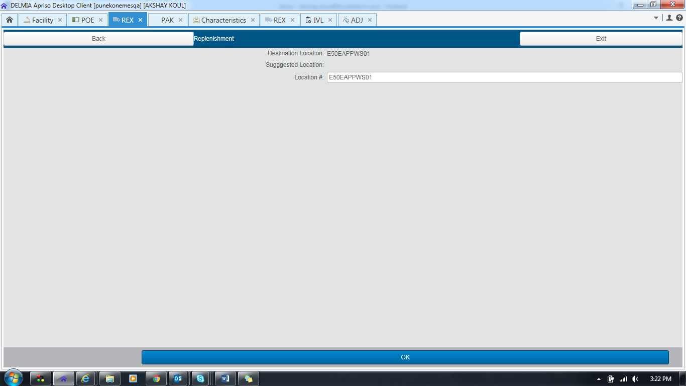

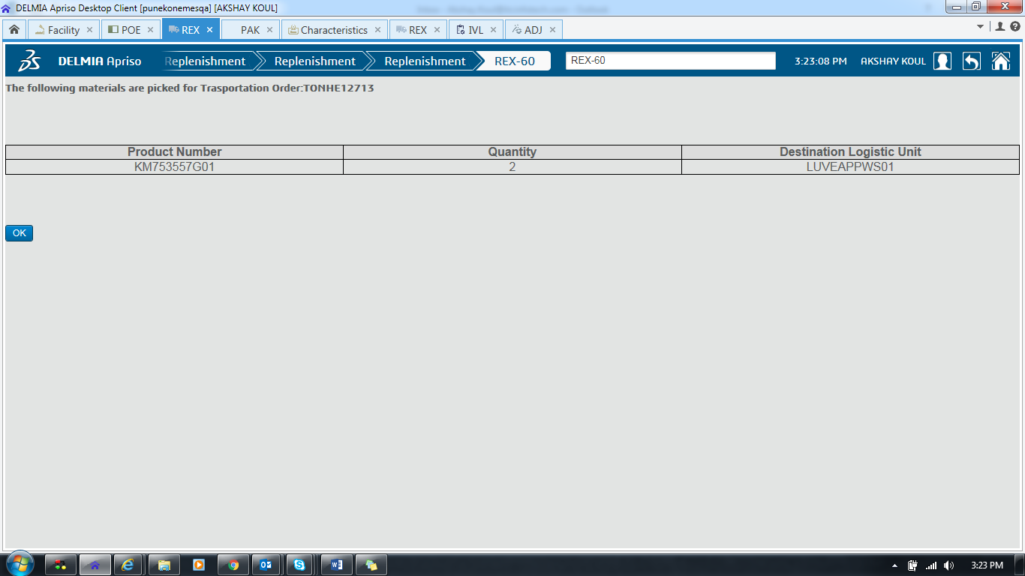

**Case 4**

**TO Creation NEW**

**REX Execution NEW**

**Facility KNEE**

**Go to unit Characteristics K1X_POE_MATERIALCALL**

**Attribute LUBASED_MATERIALCALL_USINGMAV**

**TO Creation (NEW)**

**REX Execution (NEW) Unit Characteristics K1X_REX_Method**

**Attribute LU_BASED_REX_USING_MAV**

**Screen POE**

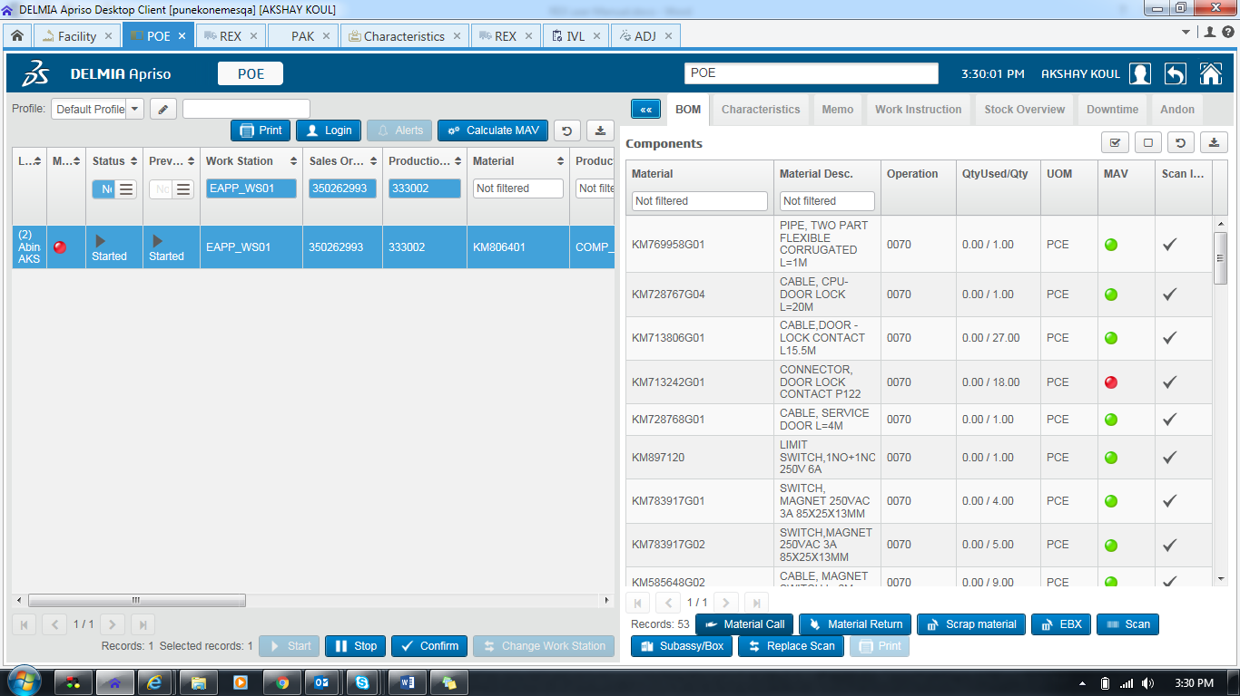

Here TO creation is NEW

TO should be created on basis of MAV Calculation i.e. for RED, Grey, orange items

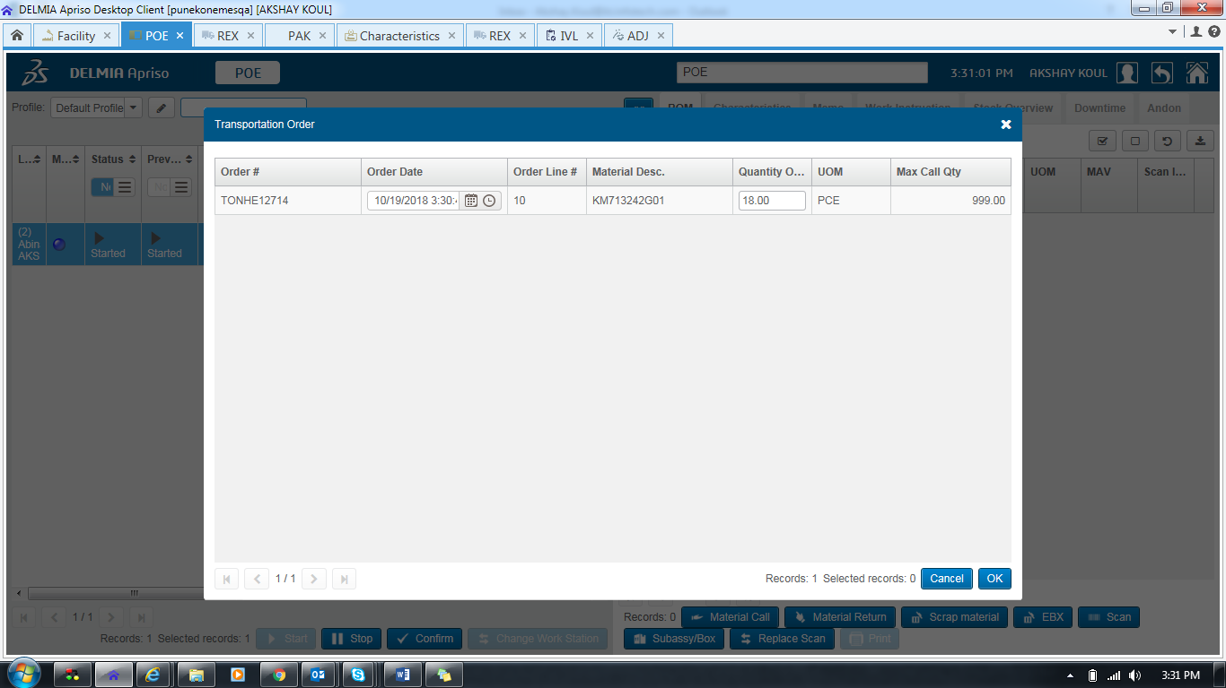

Navigate to REX Screen

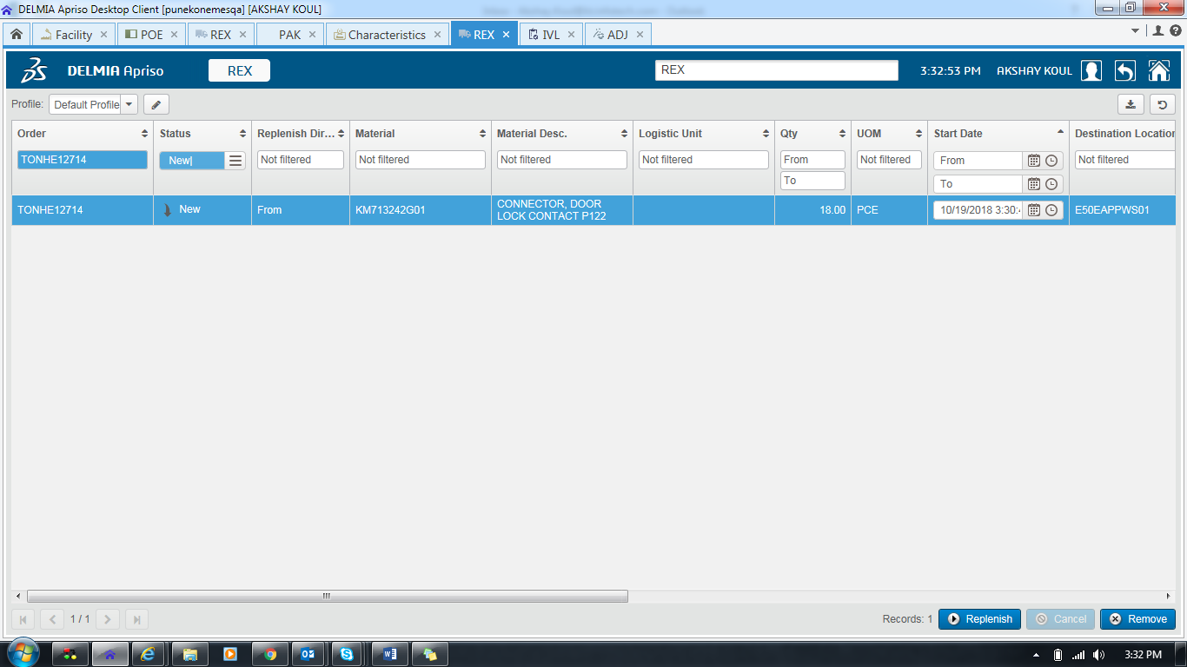

TO Generated As expected

REX

Execution As expected

